Deployment manual

How to deploy on SFA cluster

Open an elevated Windows Commandline terminal.

Cmd als admin ausführen

route add 192.168.50.0 mask 255.255.255.0 192.168.30.126

The format is as follows: route add [BRE-HV03 network card 1] mask [mask] [BRE-HV03 net work card 2]

You basically link the two separate IP nets together.

Use route add -p for setting the route permanently. If you don’t do this, you will have to re-add the route at a later point.

In the solution, right-click on the SFA project and click Publish.

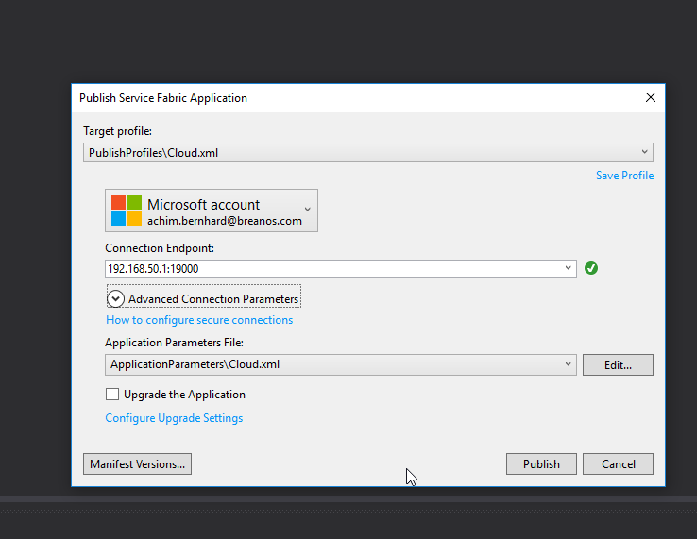

Verify deployment

